**SNU-COMPASS🧭**

**C**ollege **O**ptions and **M**inor **P**references **A**ssessment **S**upport **S**ystem

CSD317 (Introduction to Database Systems) Semester Project

# Team members:

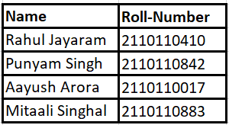

# Objective

Our project SNU-COMPASS aims at developing a user-friendly web application to address a common challenge faced by SNU students,

especially freshmen and sophomores. Many students lack clear guidance on how to pursue a Minor or Specialization alongside their major. Our app aims to bridge this knowledge gap by providing students with comprehensive information on required University Wide Electives (UWEs) for a Minor and Major Electives for a Specialization. Our goal is to simplify academic planning and empower all future SNU students to make informed decisions about their academic paths.

# Features

SNU-COMPASS is designed with a set of robust features that cater to the diverse needs of both faculty and students, revolutionizing the academic planning experience at our university.

1. **Progress Tracking for Teachers**:

Faculty members can efficiently track students' academic progress. This feature provides a comprehensive overview of the courses completed, grades obtained, and overall academic performance, enabling teachers to offer timely guidance and support.

2. **Dynamic Addition of Minor Courses:**

Teachers have the flexibility to dynamically add new courses, such as SWAYAM, to the application. These added courses are seamlessly integrated into the system, counting towards a student's minor completion. This eliminates the need for extensive email communication with students regarding course updates, ensuring a real-time and efficient process.

3. **Personalized Progress Dashboard for Minor Pursuers**:

Students pursuing a minor can access a personalized progress dashboard. This feature empowers students to visualize their academic journey, providing insights into completed and upcoming minor-related courses. The dashboard aids in effective schedule planning, ensuring students stay on track with their minor requirements.

4. **Comprehensive Course Completion Overview for Non-Minor Students**:

For students not currently pursuing a minor, the application offers a comprehensive view of course completion across all departments. This feature serves as a valuable tool for students to assess their academic progress and consider potential minor options in various departments based on their existing coursework.

5. **User-Friendly Interface**:

SNU-COMPASS boasts a user-friendly interface, ensuring ease of navigation for both faculty and students. The intuitive design facilitates seamless interaction with the application, enhancing the overall user experience.

6. **Detailed Course Information**:

The application provides detailed information about each course, including course name, description, credits, and the department offering the course. This information aids students in making informed decisions about their academic paths.

By integrating these features, SNU-COMPASS emerges as a comprehensive and innovative solution, simplifying academic planning for both faculty and students while fostering a more dynamic and responsive educational environment at Shiv Nadar University.

# ER Model

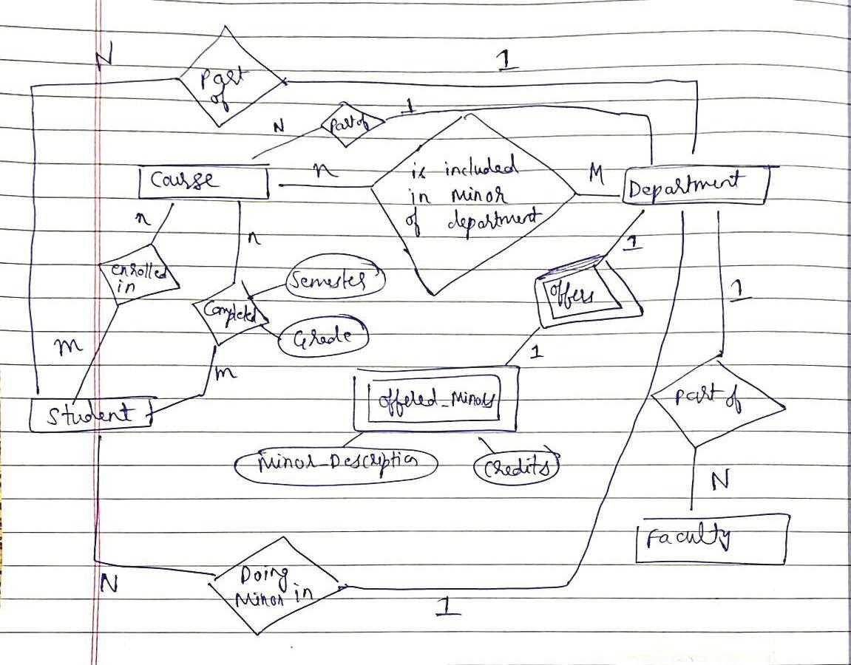

(Hand drawn ER diagram, following the pattern taught in class)

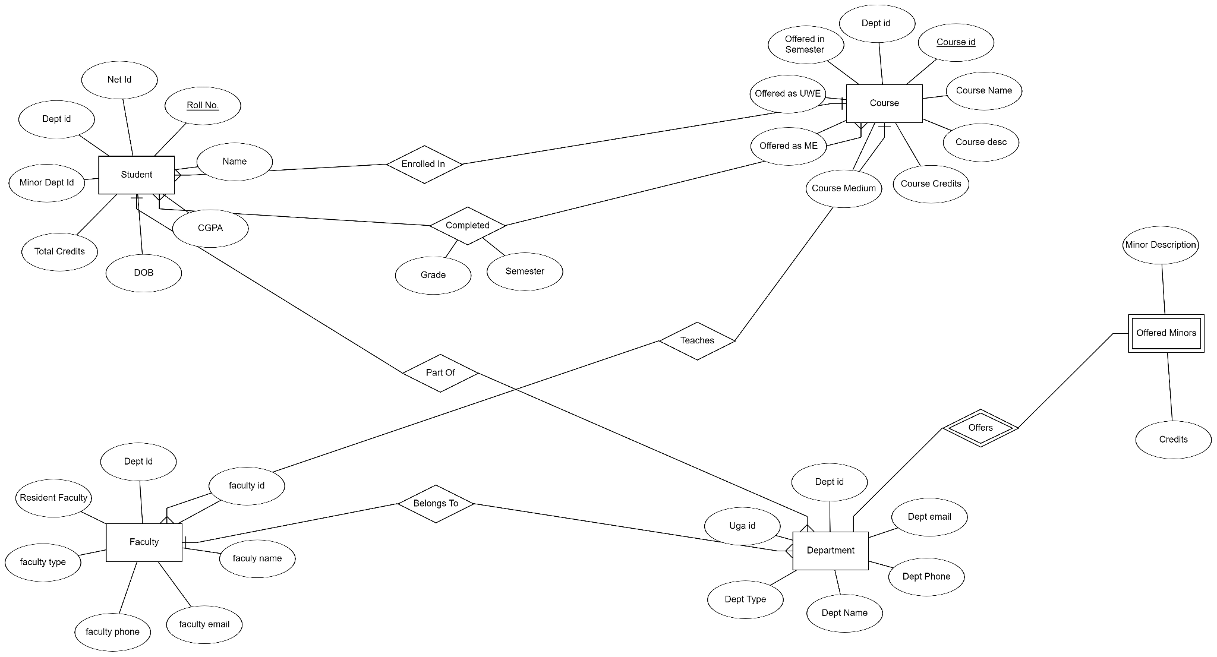

(ER Diagram made in draw.io)

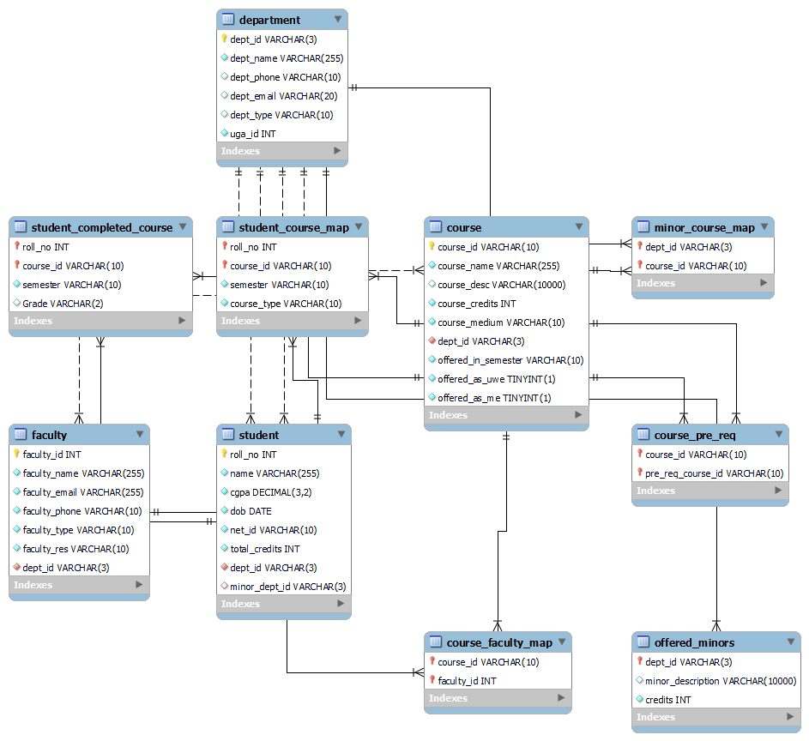

(ER diagram displaying proper information about database schema)

# Relational Model

Department



Student



Course



Faculty



Student_Course_Map



Student_Completed_Course



Minor_course_Map



Offered_minors



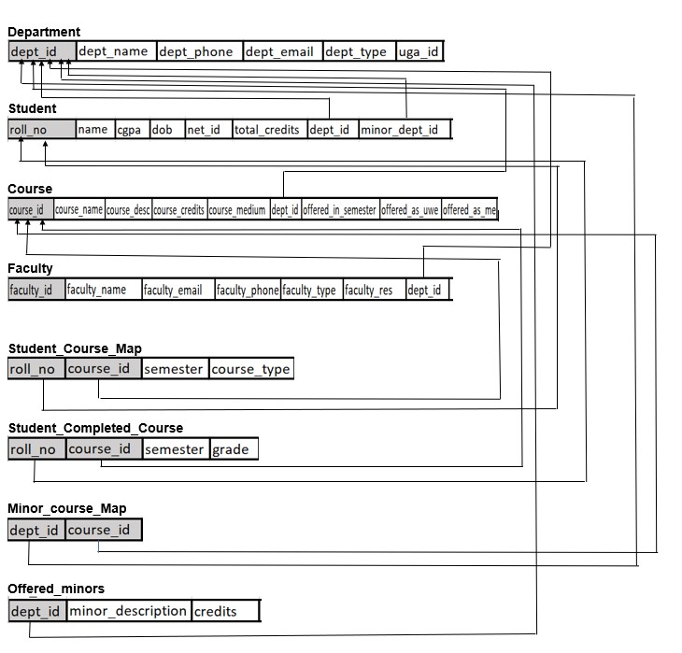

# Normalization Relations

1. Department



Here, **dept_id** is the primary key and it determines all the other non-prime attributes.

Functional Dependencies:

1. dept_id -> dept_name
2. dept_id -> dept_phone
3. dept_id -> dept_email
4. dept_id -> dept_type
5. dept_id -> uga_id

The relation is in:

1NF as it has atomic attributes.

2NF as it has no partial dependency.

3NF as it has no transitive dependency.

Hence, the relation is in **3NF**.

1. Student



Here, **roll_no** is the primary key and it determines all the other non-prime attributes.

Functional Dependencies:

1. roll_no -> name
2. roll_no -> cgpa
3. roll_no -> dob
4. roll_no -> net_id
5. roll_no -> total_credits
6. roll_no -> dept_id
7. roll_no -> minor_dept_id

The relation is in:

1NF as it has atomic attributes.

2NF as it has no partial dependency.

3NF as it has no transitive dependency.

Hence, the relation is in **3NF**.

1. Course



Here, **course_id** is the primary key and it determines all the other non-prime attributes.

Functional Dependencies:

1. course_id -> course_name
2. course_id -> course_desc
3. course_id -> course_credits
4. course_id -> course_medium
5. course_id -> dept_id
6. course_id -> offered_in_semester
7. course_id -> offered_as_uwe
8. course_id -> offered_as_me

The relation is in:

1NF as it has atomic attributes.

2NF as it has no partial dependency.

3NF as it has no transitive dependency.

Hence, the relation is in **3NF**.

1. Faculty



Here, **faculty_id** is the primary key and it determines all the other non-prime attributes.

Functional Dependencies:

1. faculty_id -> faculty_name
2. faculty_id -> faculty_email
3. faculty_id -> faculty_phone
4. faculty_id -> faculty_type
5. faculty_id -> faculty_res
6. faculty_id -> dept_id

The relation is in:

1NF as it has atomic attributes.

2NF as it has no partial dependency.

3NF as it has no transitive dependency.

Hence, the relation is in **3NF**.

1. Student_Course_Map



Here, **roll_no & course_id** together are the primary keys, and they determine all the other non-prime attributes.

Functional Dependencies:

1. (roll_no, course_id) -> semester
2. (roll_no, course_id) -> course_type

The relation is in:

1NF as it has atomic attributes.

2NF as it has no partial dependency.

3NF as it has no transitive dependency.

Hence, the relation is in **3NF**.

1. Student_Completed_Course



Here, **roll_no & course_id** together are the primary keys, and they determine all the other non-prime attributes.

Functional Dependencies:

1. (roll_no, course_id) -> semester
2. (roll_no, course_id) -> grade

The relation is in:

1NF as it has atomic attributes.

2NF as it has no partial dependency.

3NF as it has no transitive dependency.

Hence, the relation is in **3NF**.

1. Minor_course_map



Here, **dept_id & course_id** together are the primary keys.

The relation is in:

1NF as it has atomic attributes.

2NF as it has no partial dependency.

3NF as it has no transitive dependency.

Hence, the relation is in **3NF**.

1. Offered_minors



Here, **dept_id** is the primary key.

Functional Dependencies:

1. dept_id -> minor_description
2. dept_id -> credits

The relation is in:

1NF as it has atomic attributes.

2NF as it has no partial dependency.

3NF as it has no transitive dependency.

Hence, the relation is in **3NF**.

# Frontend Screenshots & Backend Queries

1. GetCompletedCourse

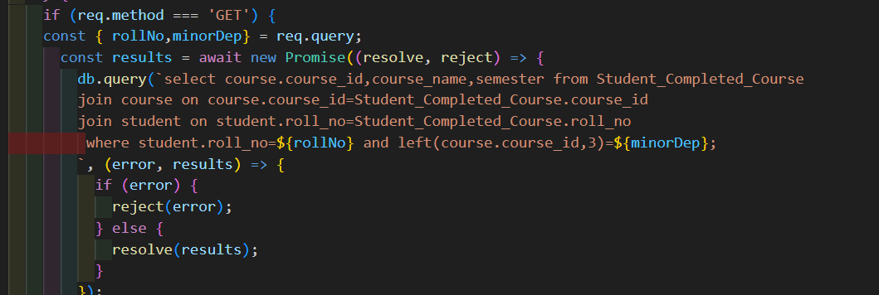

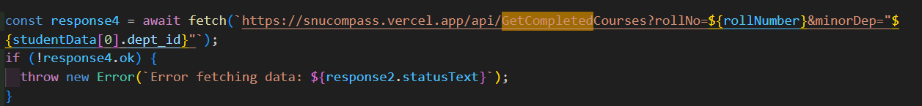

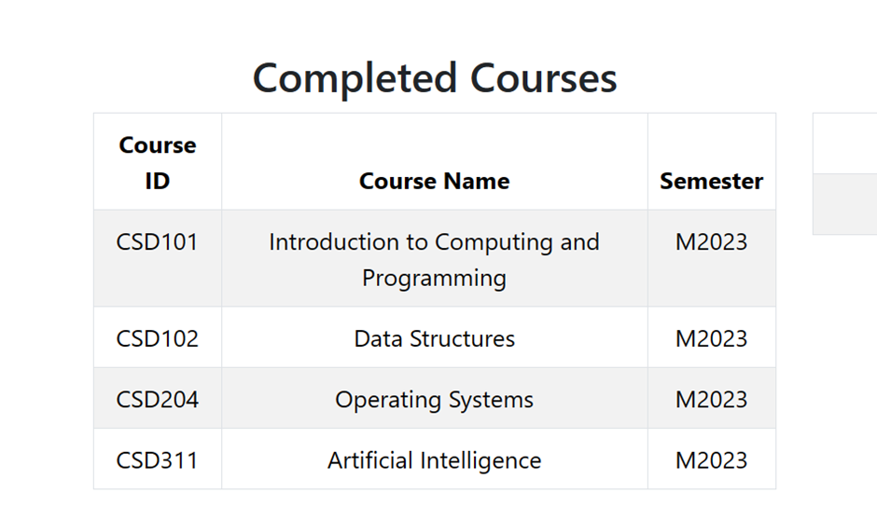

1. GetCourseList

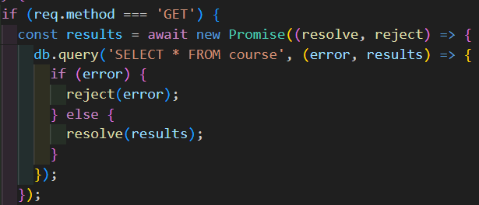

1. GetEnrolledMinorCourses

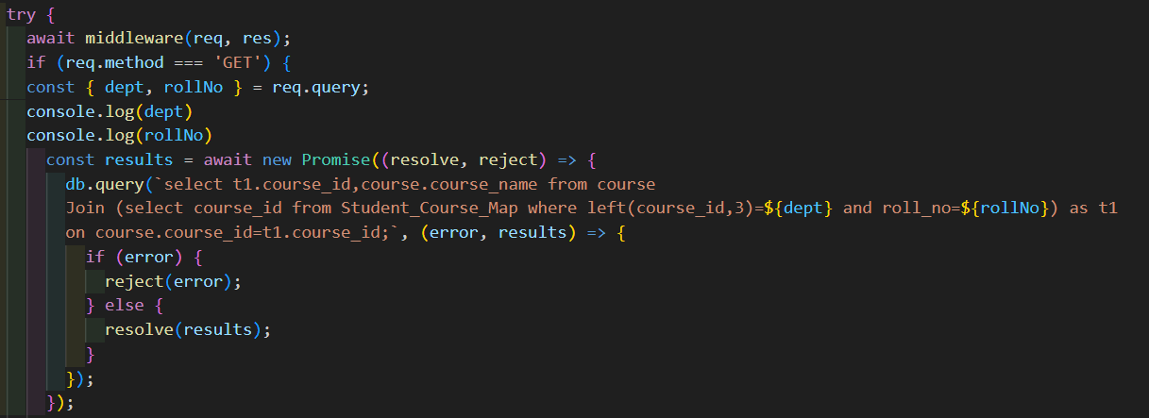

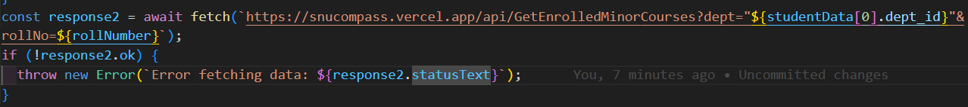

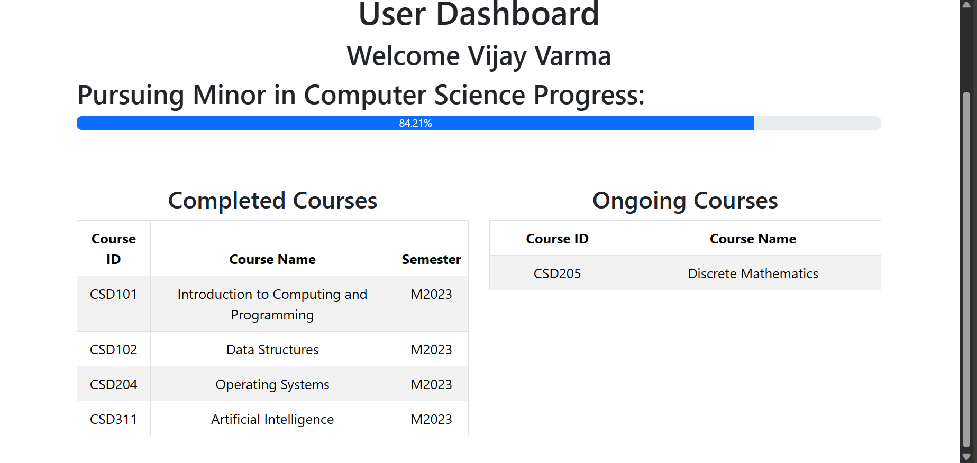

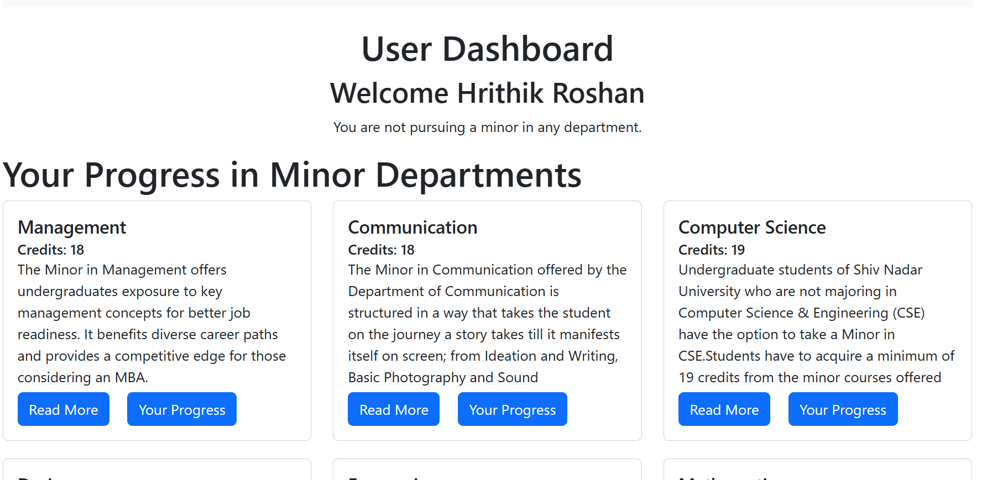

1. GetMinorDep

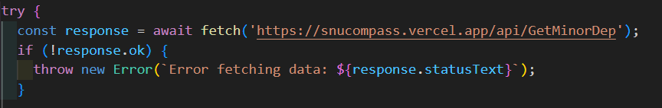

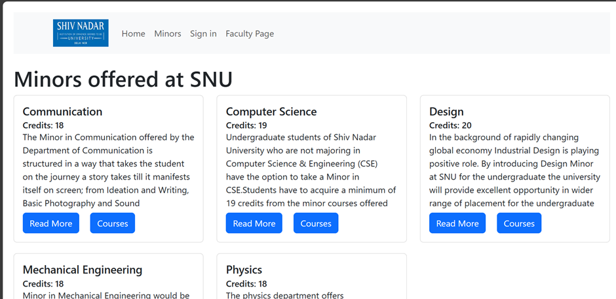

1. GetMinorCourseMap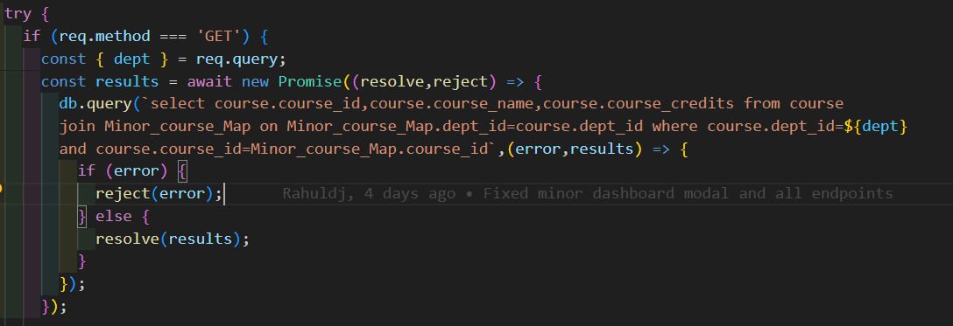



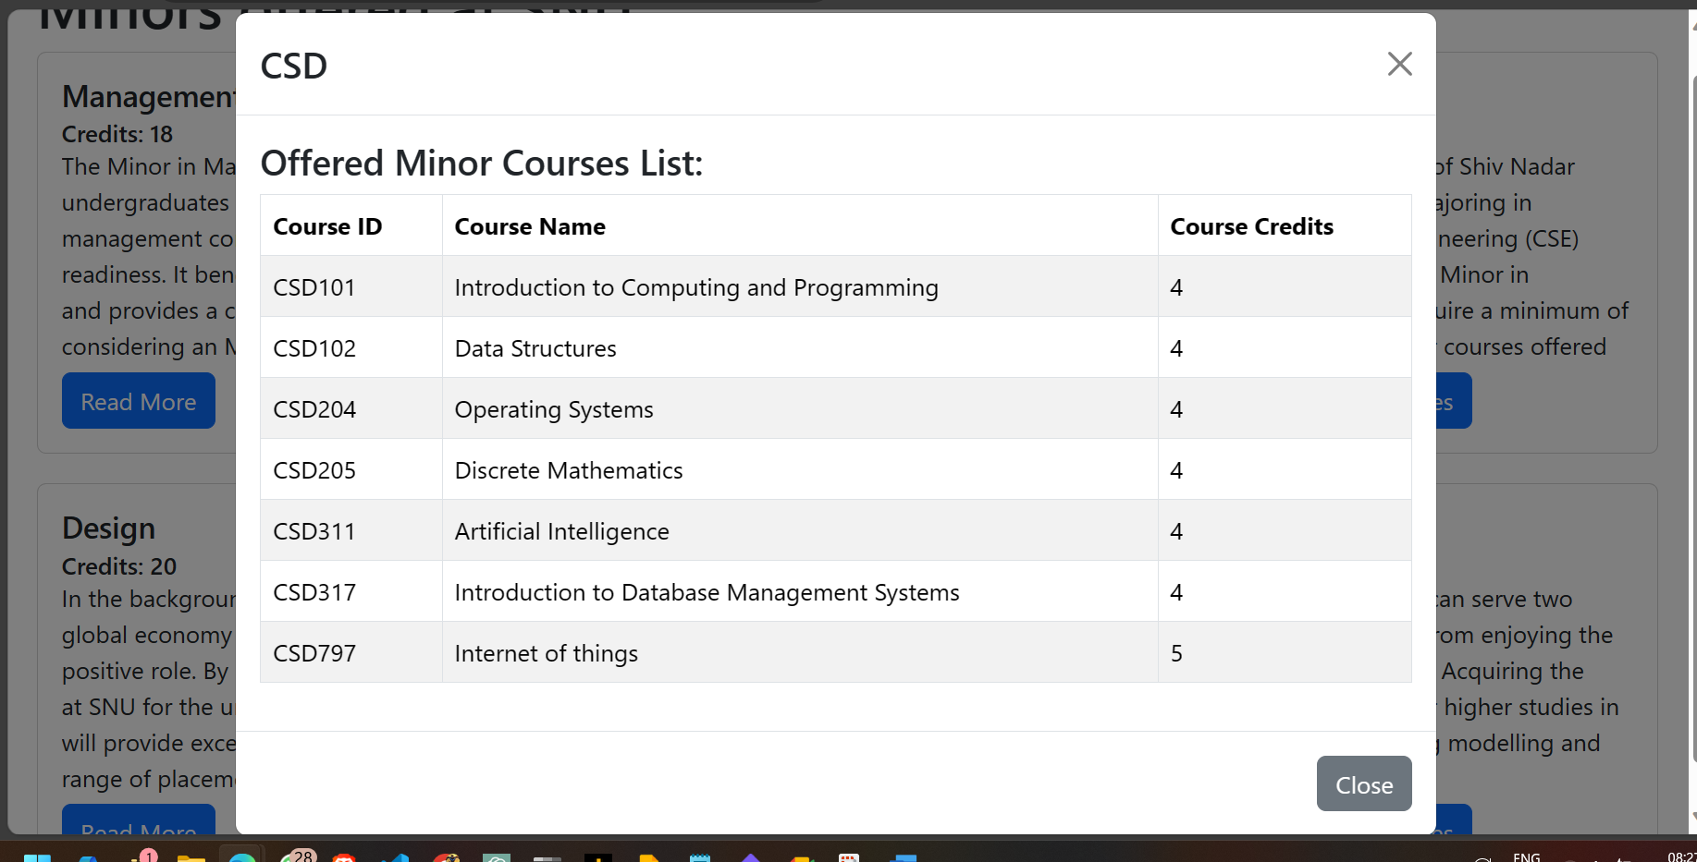

1. GetMinorStudents

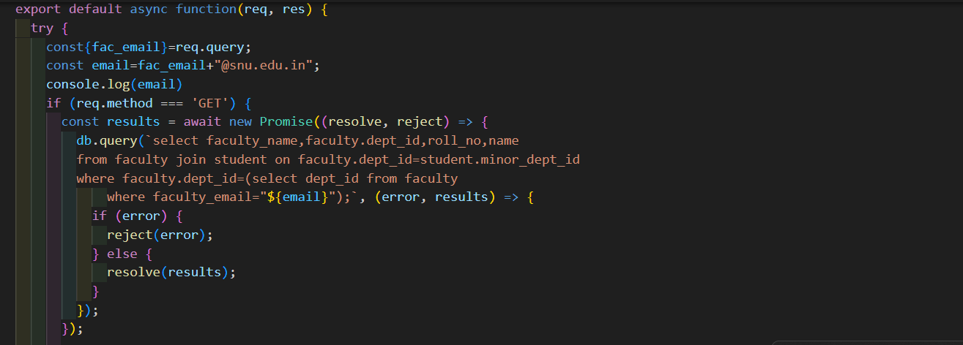

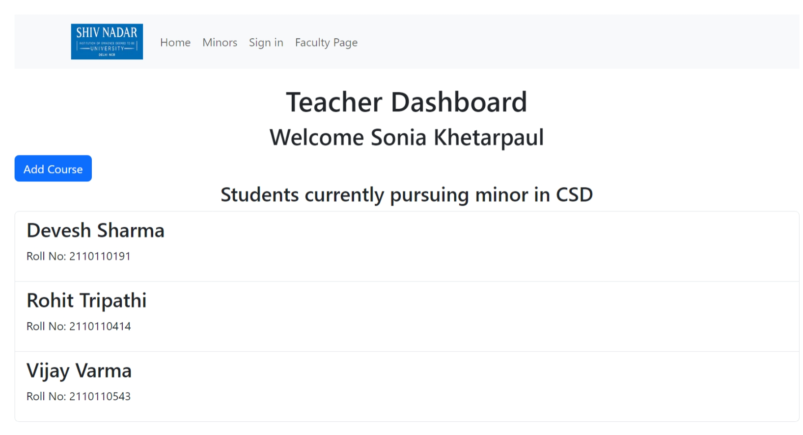

1. GetProgressPercent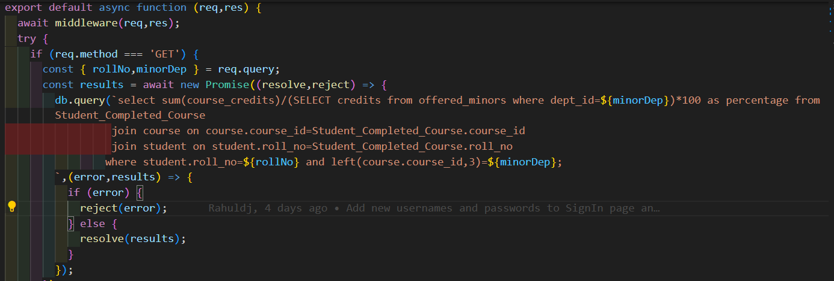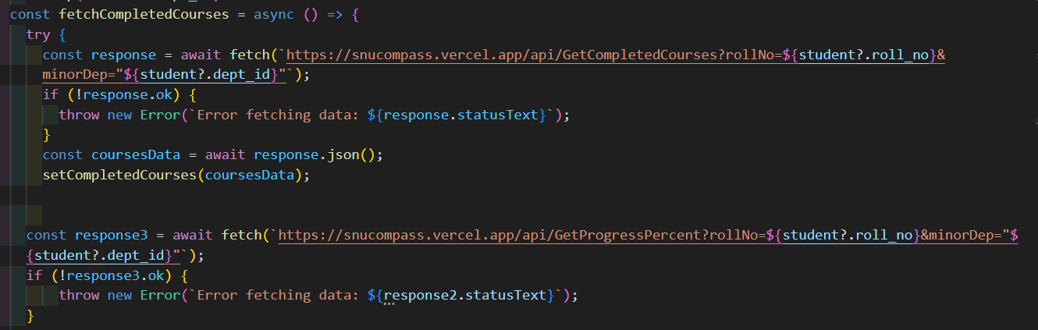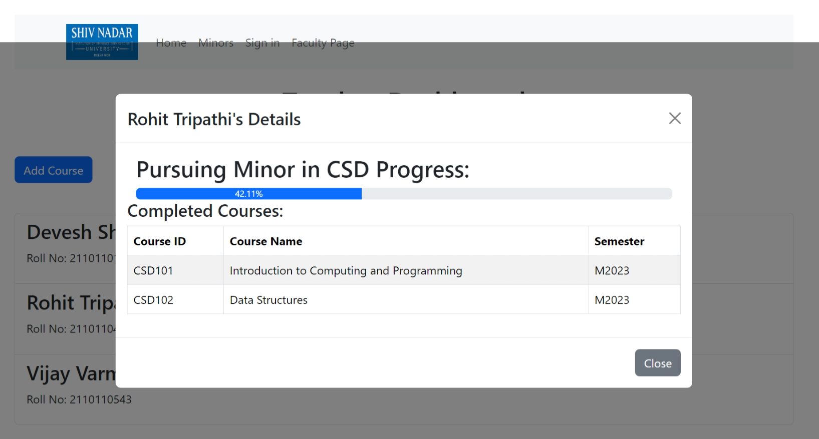
2. GetStudentData

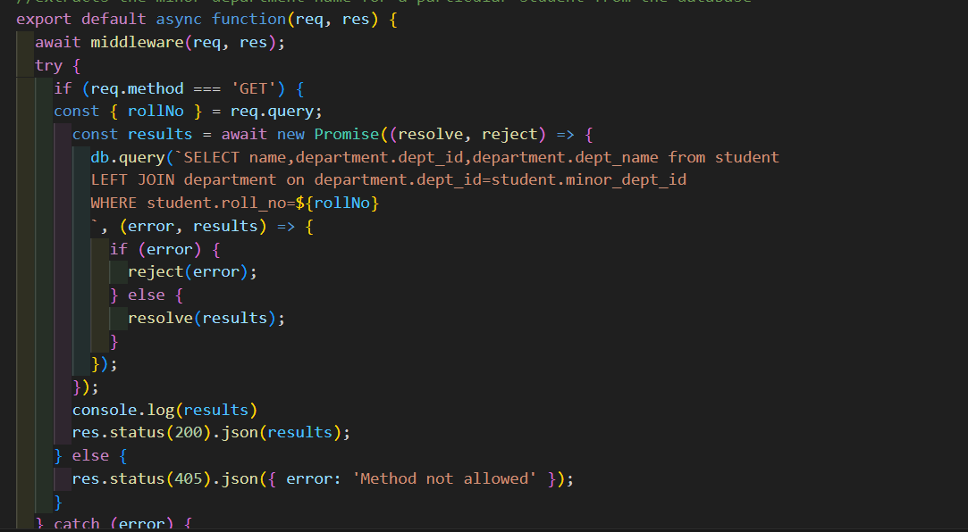

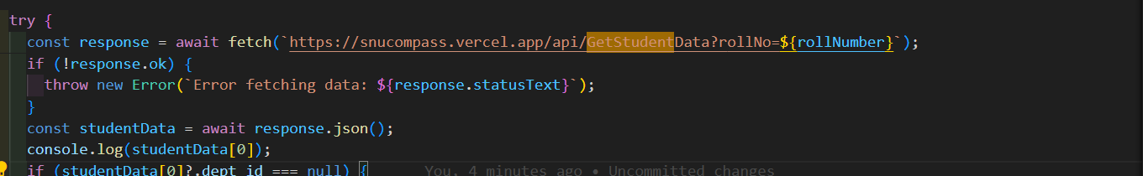



# Limitations

While SNU-COMPASS strives to provide an enhanced academic planning experience, there are certain limitations to the current implementation, primarily due to time constraints during the development phase. It is important to acknowledge these limitations for a transparent understanding of the system's scope.

1. **Consolidated View for Specializations**:

Initially, we planned to include a consolidated view for specializations offered across various departments. Unfortunately, due to time constraints, this feature could not be implemented in the current version. We recognize the significance of providing a holistic view of specializations, and while not realized in the current release, a similar model to the one described for minors can be adopted in future iterations.

2. **Limited Integration with External Systems**:

Integrating the application with external systems, such as the university's student information system or course registration system, could enhance the accuracy and efficiency of data updates. However, due to time constraints, this level of integration was not achieved in the current version.

3. **Enhanced Communication Features**:

While the application streamlines information access, it does not currently facilitate direct communication between faculty and students. Integrating enhanced communication features, such as direct messaging or discussion forums, was not within the scope of the initial release.

It is essential to recognize these limitations as areas for potential improvement and expansion in future iterations. Despite these constraints, SNU-COMPASS remains a valuable tool for simplifying academic planning and fostering informed decision-making within the SNU academic community.

# Novelty

In the academic landscape at Shiv Nadar University (SNU), students often encounter challenges in accessing accurate and current information about available minors. Traditionally, students have navigated through outdated PDF documents, resulting in a laborious process of seeking guidance through multiple email interactions with the Undergraduate Advisor (UGA).

Our project, SNU-COMPASS, pioneers a transformative solution to this long-standing issue by establishing a centralized platform that serves as a comprehensive resource for information related to minors offered by various departments at SNU. The primary novelty lies in the redefinition of a cumbersome process into a streamlined and user-friendly experience.

Key Novelty Features:

1. **One-Stop Destination**: SNU-COMPASS acts as a singular point of reference for students seeking information on available minors. Instead of navigating through multiple channels and dealing with outdated documents, students can now access a centralized and up-to-date platform.

2. **Detailed Minor Descriptions**: The application offers comprehensive explanations of minors, including course requirements, credit details, and any additional information provided by the respective departments. This surpasses the limitations of traditional documents, providing a richer understanding of the academic offerings.

3. **UGA Interaction Simplification**: Recognizing the historical reliance on email communication with the Undergraduate Advisor (UGA), our application simplifies this process. Students can now efficiently gather information about minors without the need for extensive email exchanges.

4. **Dual Functionality for Faculty and Students**: Our application recognizes the diverse needs of both faculty and students. Faculty members can use the system to manage and update minor information, contributing to a dynamic and responsive database.

By addressing the limitations of current information dissemination methods and enhancing the accessibility and clarity of minor-related data, SNU-COMPASS stands as an innovative solution, simplifying academic planning for students and promoting efficiency within the academic community at Shiv Nadar University.

# References

1. **React Bootstrap**:

The development of the user interface in SNU-COMPASS utilized React Bootstrap, a popular front-end framework that integrates Bootstrap components seamlessly with React.   
Reference: [React Bootstrap Documentation](https://react-bootstrap.github.io/)

2. **Next.js Documentation**:

Next.js played a pivotal role in building the web application, providing a robust framework for React-based server-side rendering and routing.   
Reference: [Next.js Documentation](https://nextjs.org/docs)

3. **MySQL Documentation (W3Schools)**:

The project leveraged MySQL for the database management system. The W3Schools documentation for MySQL served as a valuable resource for understanding and implementing database queries and interactions.   
Reference: [W3Schools MySQL Documentation](https://www.w3schools.com/sql/)